‘Bring a Friend’ Event

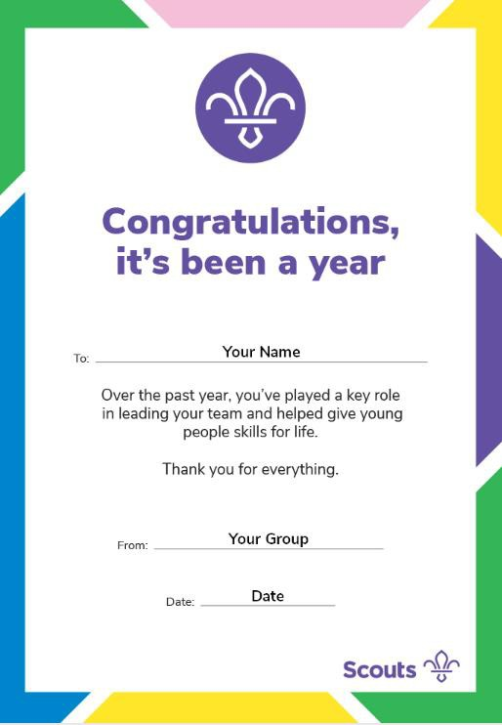

This is a special invitation for

To join my friends and I for some awesome Scouting fun! Please come along to our meeting to see what Scouting is all about.

Invitation from:

When:

Where:

My Leader:

Parents are also invited to come along, meet the

leaders and see what we do.

Group Name:

Street Address:

Contact Number:

Contact Email:

All scouting activities are supervised by trained Adult leaders. All adult leaders in scouting undergo DBS checks and complete safety and safeguarding training.